BUSINESS INSIGHT REPORT
Interactive Sales Dashboard Analysis

Dataset Name: GLOBAL SALES & FINANCIAL PERFORMANCE
Student Name: PRASANTH
Prepared using Microsoft Power BI

1. Introduction
This report presents a detailed analysis of the “Global Sales & Financial Performance” dataset, visualised through an interactive Power BI dashboard. The purpose of this report is to translate the dashboard's visual insights into a structured business document that highlights key performance indicators, sales trends, and operational patterns across products, regions, time periods, and employees.
The analysis aims to help decision-makers understand how the business is performing overall, identify the strongest and weakest areas of the business, and provide data-driven recommendations that can guide inventory planning, marketing strategy, regional expansion, employee management, product portfolio decisions, and customer targeting.

2. Dashboard Overview
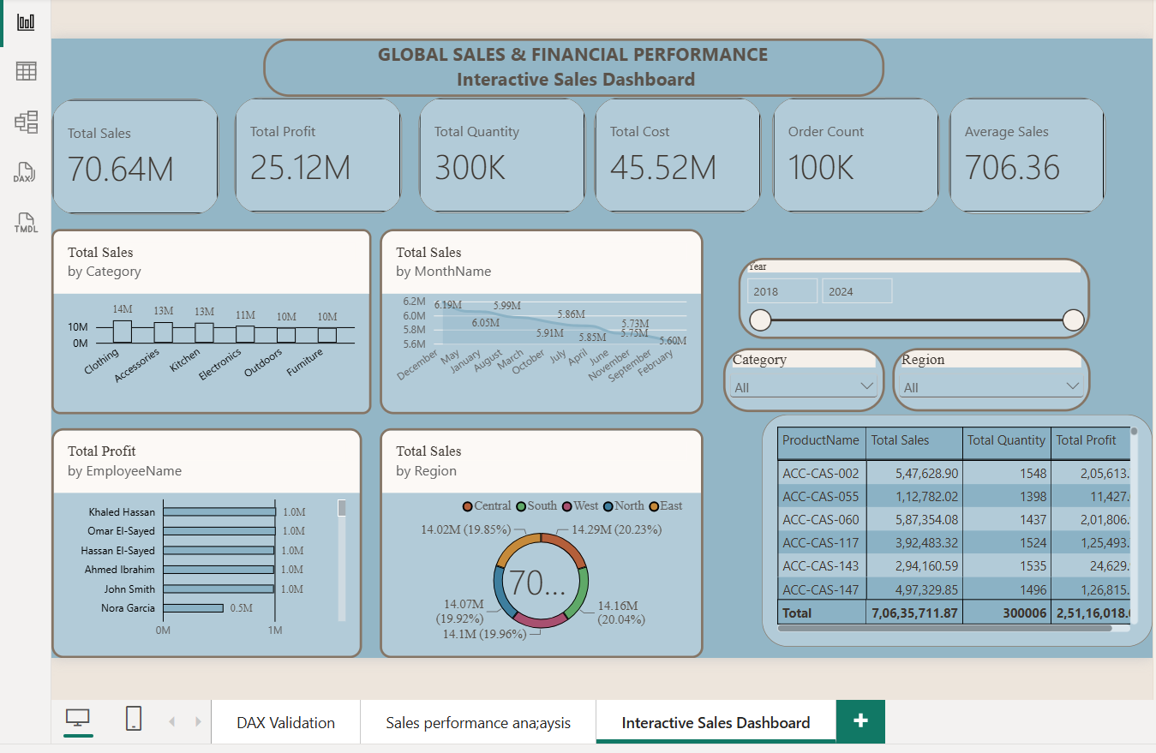
The Interactive Sales Dashboard consolidates the organisation's global sales and financial performance into a single view. It displays six headline KPI cards (Total Sales, Total Profit, Total Quantity, Total Cost, Order Count, and Average Sales) alongside visuals that break down performance by product category, month, employee, and region. A year-range slider and Category/Region filters allow users to interactively drill into specific time periods or business segments, while a detailed product-level table on the right supports granular, row-level investigation.

3. KPI Analysis
The dashboard's KPI cards summarise the overall health of the business across the reporting period:
Total Sales  70.64M | Total Profit  25.12M | Total Quantity  300K
Total Cost  45.52M | Order Count  100K | Average Sales  706.36

The business generated total sales of approximately 70.64M against a total cost of 45.52M, yielding a total profit of 25.12M — an overall profit margin of roughly 35.5%. With around 100K orders and 300K units sold, the average order carries close to 3 units, and the average sale value per order is 706.36. This indicates a healthy, moderately high-margin business built on a large volume of mid-sized transactions rather than a small number of very large orders.

4. Product Category Performance Analysis
The “Total Sales by Category” chart breaks total revenue down across six product categories: Clothing, Accessories, Kitchen, Electronics, Outdoors, and Furniture.
- Clothing leads the portfolio with approximately 14M in sales, making it the top-performing category.
- Accessories and Kitchen follow closely, each contributing around 13M.
- Electronics contributes roughly 11M, positioning it as a solid mid-tier performer.
- Outdoors and Furniture are the smallest contributors, each generating around 10M in sales.
Overall, sales are fairly evenly distributed across categories, with only a moderate gap (roughly 4M) between the strongest (Clothing) and weakest (Outdoors/Furniture) categories. This suggests a diversified product portfolio without heavy dependence on a single category, though Clothing, Accessories, and Kitchen together account for the majority of revenue.

5. Monthly Sales Trend Analysis
The “Total Sales by MonthName” line chart tracks revenue across all twelve months of the year, with values ranging narrowly between approximately 5.60M and 6.19M per month.
- December records the highest monthly sales at approximately 6.19M, suggesting a seasonal peak likely linked to year-end and holiday purchasing.
- May and January also perform strongly, each close to 6.0M.
- February shows the lowest monthly sales at approximately 5.60M, indicating a post-holiday slowdown.
- The remaining months (March, April, June, July, August, September, October, and November) stay within a tight band of roughly 5.7M–5.9M, reflecting stable, consistent demand through the rest of the year.
The relatively narrow range between the highest and lowest months (a spread of under 700K) indicates that the business experiences only mild seasonality, with demand remaining broadly predictable throughout the year rather than being concentrated in a few peak months.

6. Regional Sales Analysis
The “Total Sales by Region” donut chart divides total sales across five regions — Central, South, West, North, and East — each contributing close to one-fifth of total revenue:
Region | Total Sales | Share of Total
South | 14.29M | 20.23%
West | 14.16M | 20.04%
North | 14.10M | 19.96%
East | 14.07M | 19.92%
Central | 14.02M | 19.85%

Regional performance is remarkably balanced, with each region contributing between 19.85% and 20.23% of total sales — a spread of less than half a percentage point. South is the strongest region, narrowly ahead of West and North, while Central and East trail marginally behind. This even distribution suggests the business has achieved a mature, well-established geographic footprint rather than being dependent on any single region.

7. Employee Performance Analysis
The “Total Profit by EmployeeName” chart ranks employees by the profit they have generated. Among the employees visible on the dashboard:
- Khaled Hassan, Omar El-Sayed, Hassan El-Sayed, Ahmed Ibrahim, and John Smith each generate approximately 1.0M in profit, forming a strong, closely-matched top tier of performers.
- Nora Garcia generates approximately 0.5M, noticeably below the top-performing group.
- The chart is scrollable, indicating additional employees contribute to the remaining share of the 25.12M total profit beyond those shown at the top of the list.
The top five employees perform very consistently, suggesting a well-trained core sales team with repeatable performance standards. The visible gap for Nora Garcia may warrant closer review — whether due to role differences (e.g., part-time, newer hire, or a different territory) or a genuine performance gap that could benefit from coaching or additional support.

8. Business Recommendations
Inventory Planning
- Maintain higher stock levels for Clothing, Accessories, and Kitchen items, as they consistently drive the largest share of revenue.
- Build modest inventory buffers ahead of December and the January–May window to meet peak seasonal demand without over-stocking during the February slowdown.
Marketing Strategy
- Launch targeted promotions in February to counteract the seasonal dip in sales observed after the holiday period.
- Invest in cross-selling and bundling campaigns between top categories (Clothing/Accessories) and slower categories (Outdoors/Furniture) to lift underperforming segments.
Regional Expansion
- Since all five regions perform within a tight, balanced range, replicate the operational and marketing practices of the top region (South) in the slightly lower-performing Central and East regions.
- Given the balanced footprint, consider piloting expansion into a new geographic market, using the current model as a proven template.
Employee Performance
- Use the top five performers as internal benchmarks or mentors for onboarding and coaching newer or lower-performing staff.
- Investigate the performance gap for lower-ranked employees such as Nora Garcia to determine whether it stems from role scope, tenure, or a genuine skills gap, and provide targeted support accordingly.
Product Portfolio
- Consider expanding the product range within high-performing categories (Clothing, Accessories, Kitchen) to capture further demand.
- Review the Outdoors and Furniture categories for opportunities to refresh the assortment, adjust pricing, or improve merchandising to close the gap with top categories.
Customer Targeting
- Leverage the consistent, high-volume, mid-value order pattern (average sale of 706.36) to design loyalty programmes that encourage repeat purchases.
- Segment customers by category preference (e.g., Clothing buyers vs. Electronics buyers) to enable more personalised marketing and higher conversion rates.

In summary, the business demonstrates strong overall profitability, a diversified product portfolio, stable seasonal demand, and a well-balanced regional presence. The recommendations above focus on reinforcing these strengths while addressing the smaller pockets of underperformance identified in the category, seasonal, and employee analyses.

